1- Run test with lambdaTest tool - result  
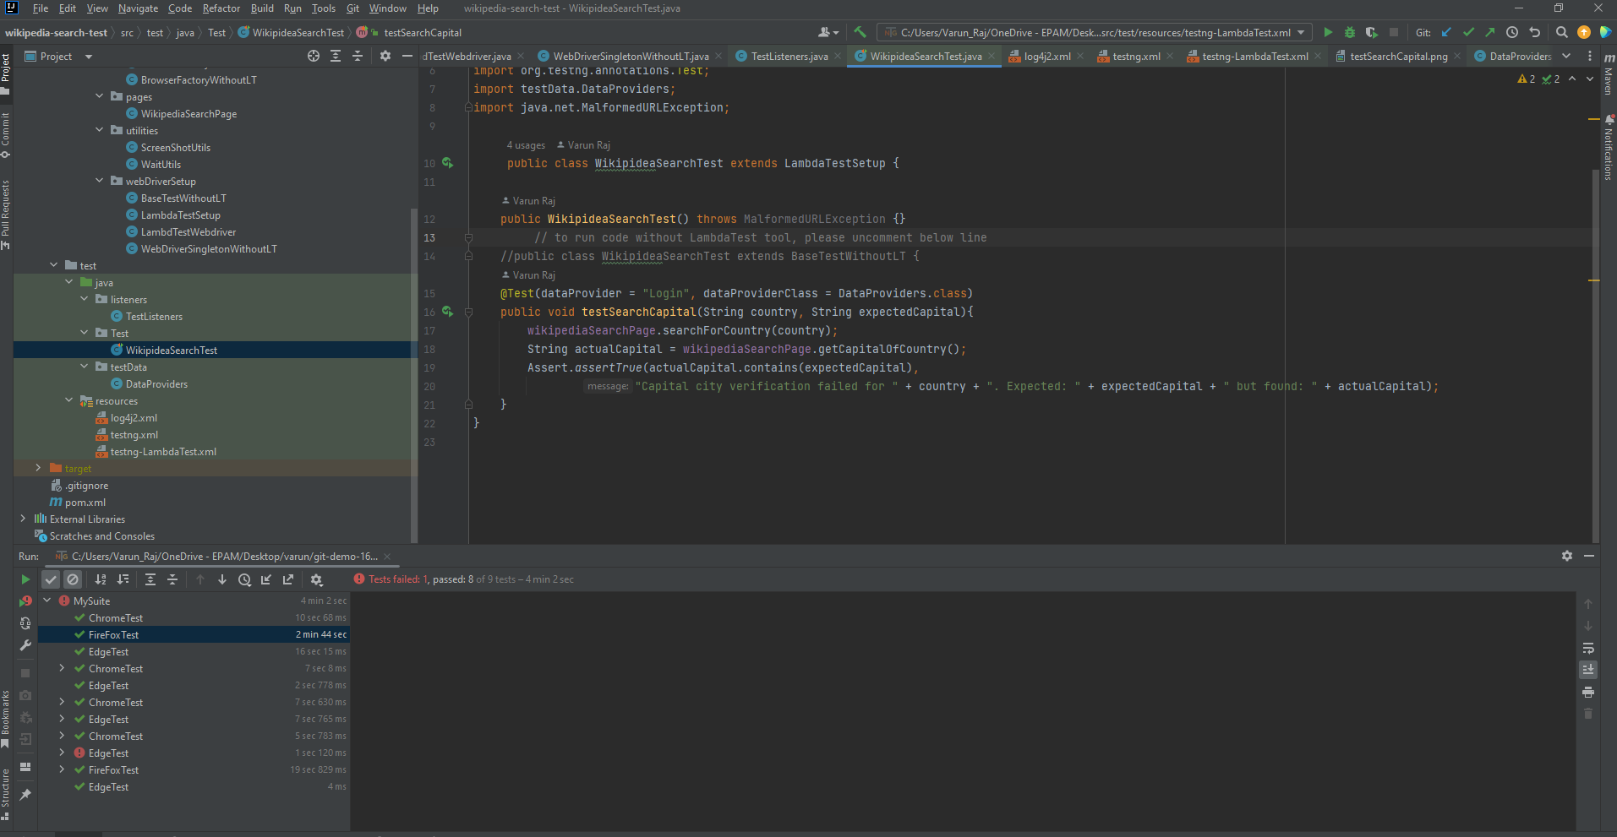  
  
  
Lambda result  
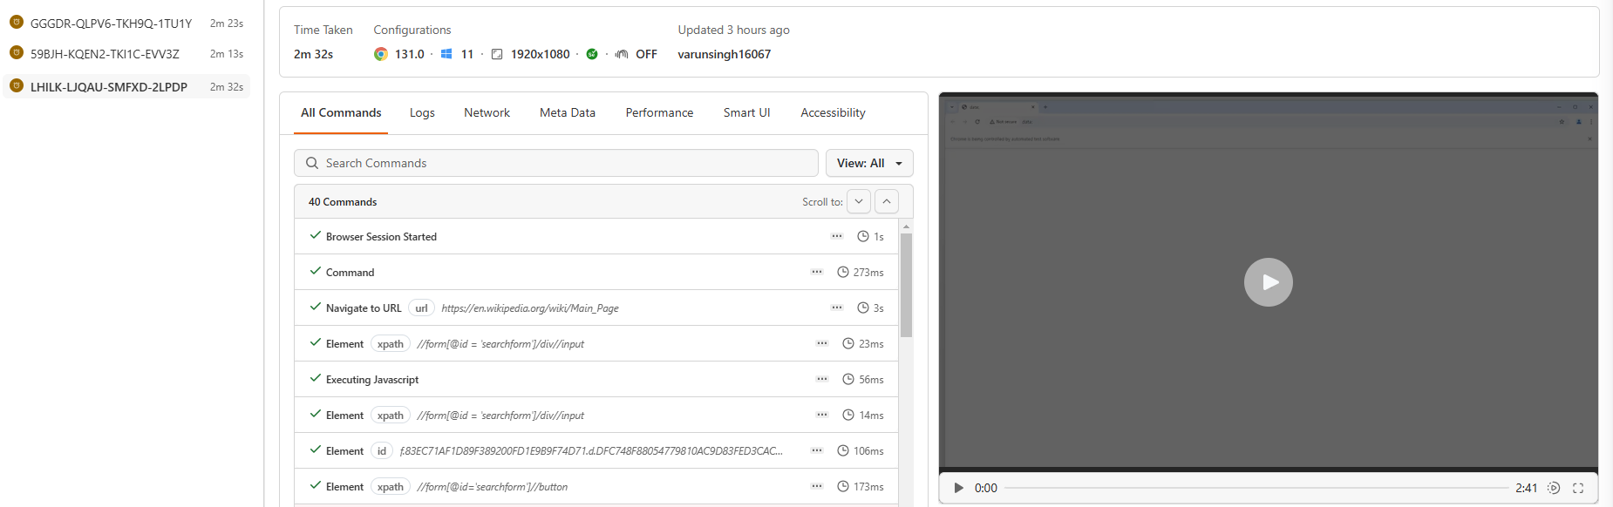

Run Wikipedia search test on local  
